9/12/2025 Briana-Yves 1-1 Meeting Minutes

Craniopharyngiomas are benign tumors that arise above the pituitary gland and often extend into the third ventricle, disrupting the ventricular floor and involving the underlying hypothalamus. Despite their benign histology, these lesions can lead to significant complications, including endocrine dysfunction, visual impairment, and hydrocephalus. Surgical management is particularly challenging due to their proximity to critical neurovascular structures and the hypothalamic-pituitary axis.

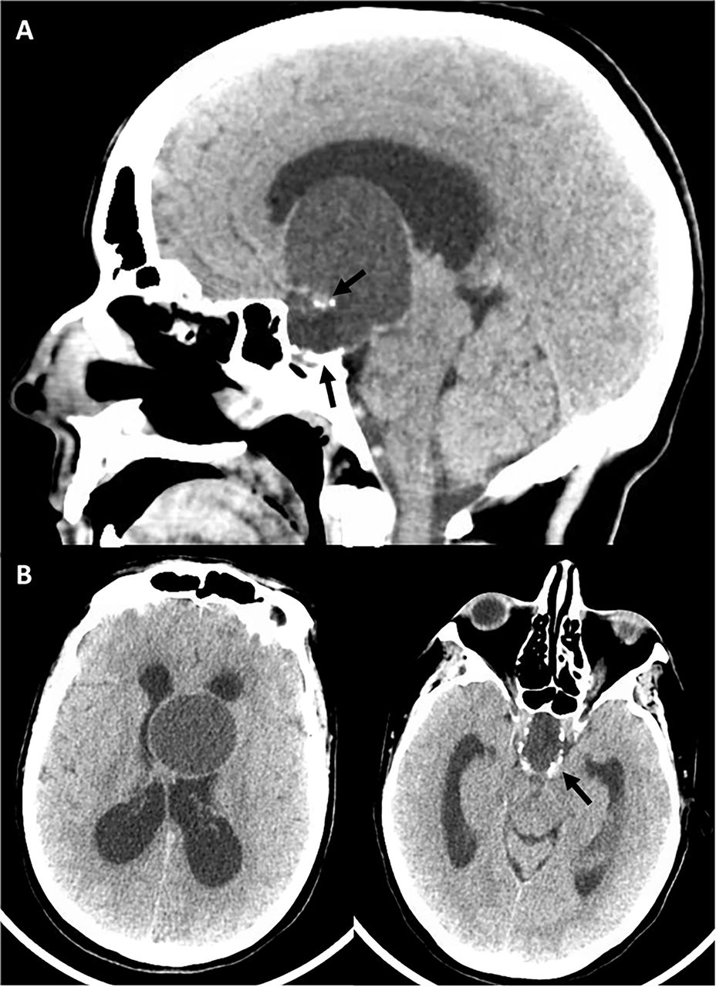
Intraventricular craniopharyngioma

We discussed different approaches for CP segmentation:
- Use a foundation MRI pre-trained model like SAM ([1]), SAM-2 ([2]), or MRI-CORE ([3]) fine-tuned it on the 90 patients, using a compactness metric, which was published in the context of tumor invasiveness.
- Augment the data and train a nnUnet model, which performs well on small datasets.
- Alternatively, use a trained model on glioblastoma multiform (gbm) and tune it on the CP MRI scans. This could be difficult, as GBM tumors have a distinct shape and intensity compared to CP.

The primary immediate focus of our project is CP auto segmentation.
A future potential research idea could be to perform auto segmentation of both the third ventricle and the craniopharyngioma tumor and investigate the invasiveness reported by the deep learning model and a clinical measurement of the tumor compactness.
We may also consider other clinical variables, such as tumor volume and the tumor's position relative to the sellar region, as well as other collected clinical variables, to investigate their association. Lastly, we can also repeat the tumor classification experiment performed by Xiarong Yan et al. ([1]).
Note that ventricle segmentation in MRI images can be performed using automatic thresholding methods like Otsu’s or ISODATA algorithms, or through statistical classification techniques such as the Expectation–Maximization (EM) algorithm for tissue classification.

- Kirillov, Alexander, et al. "Segment anything." Proceedings of the IEEE/CVF international conference on computer vision. 2023.
- Ravi, Nikhila, et al. "Sam 2: Segment anything in images and videos." arXiv preprint arXiv:2408.00714 (2024).
- Gu, Hanxue, et al. "How to build the best medical image segmentation algorithm using foundation models: a comprehensive empirical study with segment anything model." arXiv preprint arXiv:2404.09957 (2024).
- Yan, X., Lin, B., Fu, J., Li, S., Wang, H., Fan, W., Fan, Y., Feng, M., Wang, R., Fan, J., Qi, S., & Jiang, C. (2023). Deep-learning-based automatic segmentation and classification for craniopharyngiomas. Frontiers in oncology, 13, 1048841. https://doi.org/10.3389/fonc.2023.1048841

